[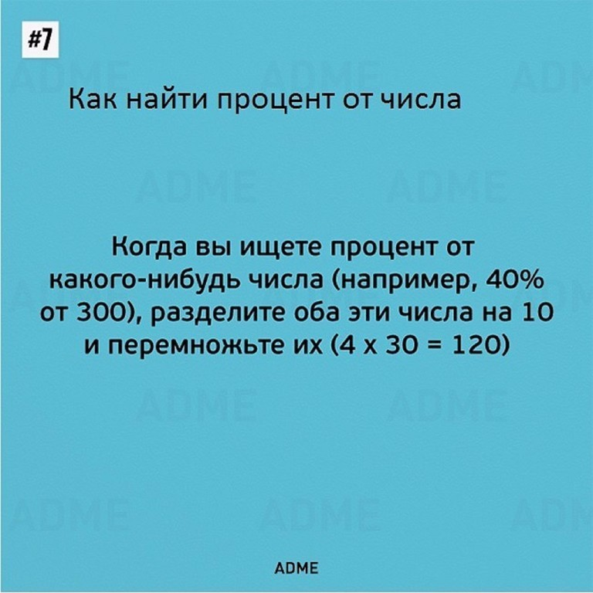](http://ok.ru/dk?cmd=PopLayerPhoto&st.layer.cmd=PopLayerPhotoOuter&st.layer.type=FRIEND&st.layer.revNav=off&st.layer.limitedUi=false&st.layer.sphotoIds=804015237720%3B804015237464%3B804015237208%3B804015236952%3B804015236696%3B804015236440&st.layer.fre=on&st.layer.showNav=on&st.layer.photoAlbumId=550397597784&st.layer.epm=off&st.layer.photoId=804015237720&st.layer.opl=off&st.layer.navStartPhotoId=804015237720&st.layer.sbd=off&st.cmd=userStatuses&st._aid=StatusLayer_openPhotoLayer)

[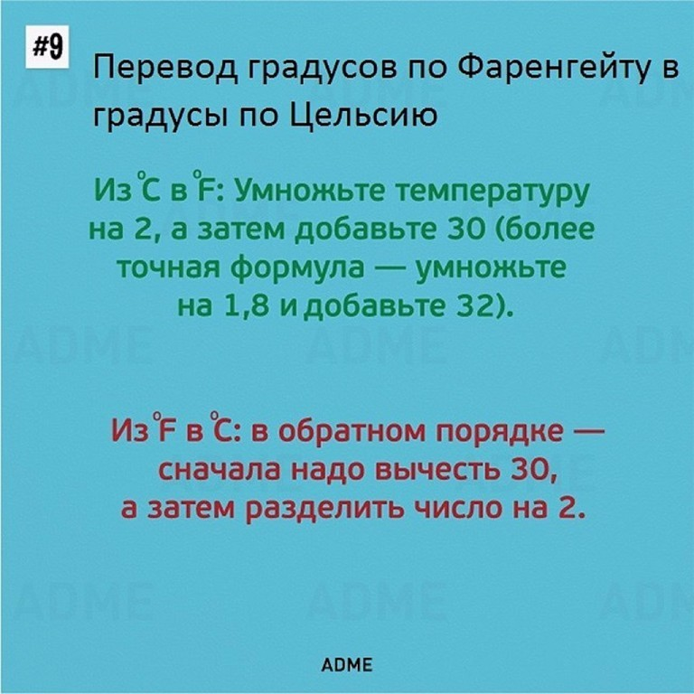](http://ok.ru/dk?cmd=PopLayerPhoto&st.layer.cmd=PopLayerPhotoOuter&st.layer.type=FRIEND&st.layer.revNav=off&st.layer.limitedUi=false&st.layer.sphotoIds=804015237720%3B804015237464%3B804015237208%3B804015236952%3B804015236696%3B804015236440&st.layer.fre=on&st.layer.showNav=on&st.layer.photoAlbumId=550397597784&st.layer.epm=off&st.layer.photoId=804015237464&st.layer.opl=off&st.layer.navStartPhotoId=804015237464&st.layer.sbd=off&st.cmd=userStatuses&st._aid=StatusLayer_openPhotoLayer)

[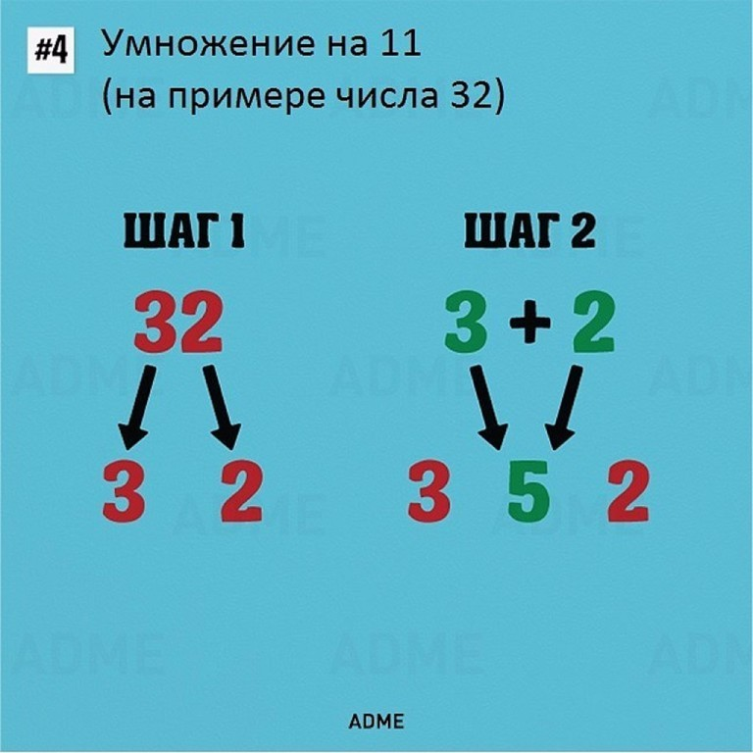](http://ok.ru/dk?cmd=PopLayerPhoto&st.layer.cmd=PopLayerPhotoOuter&st.layer.type=FRIEND&st.layer.revNav=off&st.layer.limitedUi=false&st.layer.sphotoIds=804015237720%3B804015237464%3B804015237208%3B804015236952%3B804015236696%3B804015236440&st.layer.fre=on&st.layer.showNav=on&st.layer.photoAlbumId=550397597784&st.layer.epm=off&st.layer.photoId=804015237208&st.layer.opl=off&st.layer.navStartPhotoId=804015237208&st.layer.sbd=off&st.cmd=userStatuses&st._aid=StatusLayer_openPhotoLayer)

[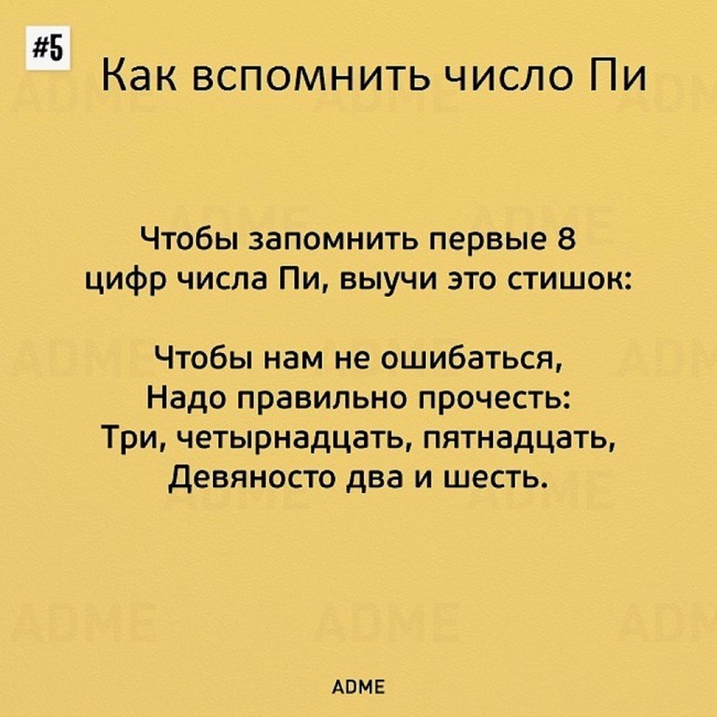](http://ok.ru/dk?cmd=PopLayerPhoto&st.layer.cmd=PopLayerPhotoOuter&st.layer.type=FRIEND&st.layer.revNav=off&st.layer.limitedUi=false&st.layer.sphotoIds=804015237720%3B804015237464%3B804015237208%3B804015236952%3B804015236696%3B804015236440&st.layer.fre=on&st.layer.showNav=on&st.layer.photoAlbumId=550397597784&st.layer.epm=off&st.layer.photoId=804015236952&st.layer.opl=off&st.layer.navStartPhotoId=804015236952&st.layer.sbd=off&st.cmd=userStatuses&st._aid=StatusLayer_openPhotoLayer)

[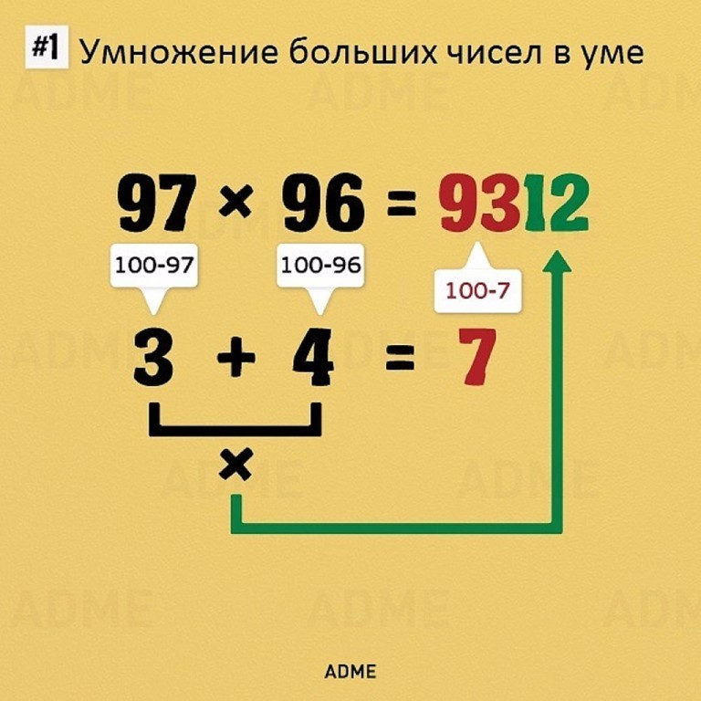](http://ok.ru/dk?cmd=PopLayerPhoto&st.layer.cmd=PopLayerPhotoOuter&st.layer.type=FRIEND&st.layer.revNav=off&st.layer.limitedUi=false&st.layer.sphotoIds=804015237720%3B804015237464%3B804015237208%3B804015236952%3B804015236696%3B804015236440&st.layer.fre=on&st.layer.showNav=on&st.layer.photoAlbumId=550397597784&st.layer.epm=off&st.layer.photoId=804015236696&st.layer.opl=off&st.layer.navStartPhotoId=804015236696&st.layer.sbd=off&st.cmd=userStatuses&st._aid=StatusLayer_openPhotoLayer)

[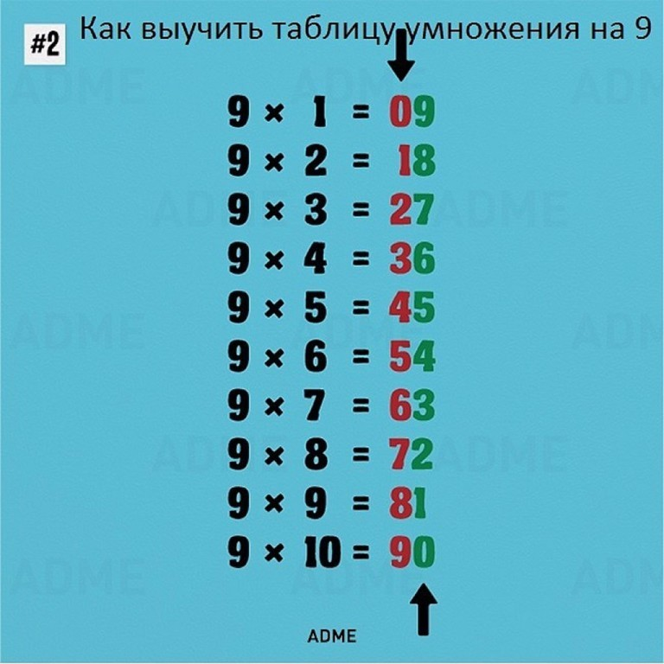](http://ok.ru/dk?cmd=PopLayerPhoto&st.layer.cmd=PopLayerPhotoOuter&st.layer.type=FRIEND&st.layer.revNav=off&st.layer.limitedUi=false&st.layer.sphotoIds=804015237720%3B804015237464%3B804015237208%3B804015236952%3B804015236696%3B804015236440&st.layer.fre=on&st.layer.showNav=on&st.layer.photoAlbumId=550397597784&st.layer.epm=off&st.layer.photoId=804015236440&st.layer.opl=off&st.layer.navStartPhotoId=804015236440&st.layer.sbd=off&st.cmd=userStatuses&st._aid=StatusLayer_openPhotoLayer)